# Installing Cassandra with Docker

## 

## Docker Installation

Install Docker on your operating system:

### Windows - [Instructions](https://docs.docker.com/docker-for-windows/install/)

Follow instructions in the WSL 2 backend. You will need to [install wsl](https://docs.microsoft.com/en-us/windows/wsl/install-win10) on your system.

### Mac - [Instructions](https://docs.docker.com/docker-for-mac/install/)

### Ubuntu - [Instructions](https://docs.docker.com/engine/install/ubuntu/)

Now, ensure that the Docker daemon is running. To check this, launch a terminal instance (powershell on windows, terminal on linux/mac) and run the below command:

|  |
| --- |
| docker info |

If Docker is running, then you will get a result similar to as shown below. Otherwise, you will get an error.

|  |
| --- |
| Client:  Debug Mode: false  Plugins:  scan: Docker Scan (Docker Inc., v0.3.4)  Server:  Containers: 1  Running: 0  Paused: 0  Stopped: 1  Images: 2  Server Version: 19.03.13  Storage Driver: overlay2  Backing Filesystem: extfs  Supports d_type: true  Native Overlay Diff: true  Logging Driver: json-file  Cgroup Driver: cgroupfs  Plugins:  Volume: local  Network: bridge host ipvlan macvlan null overlay  Log: awslogs fluentd gcplogs gelf journald json-file local logentries splunk syslog  Swarm: inactive  Runtimes: runc  Default Runtime: runc  Init Binary: docker-init  containerd version: 8fba4e9a7d01810a393d5d25a3621dc101981175  runc version: dc9208a3303feef5b3839f4323d9beb36df0a9dd  init version: fec3683  Security Options:  seccomp  Profile: default  Kernel Version: 5.4.39-linuxkit  Operating System: Docker Desktop  OSType: linux  Architecture: x86_64  CPUs: 2  Total Memory: 1.915GiB  Name: docker-desktop  ID: HHIB:HQRB:7VBA:LBUY:HKVJ:LFZ3:FSWZ:4ARP:74ZB:TIWO:WTMG:LHZH  Docker Root Dir: /var/lib/docker  Debug Mode: false  Registry: https://index.docker.io/v1/  Labels:  Experimental: false  Insecure Registries:  127.0.0.0/8  Live Restore Enabled: false  Product License: Community Engine |

## Installing Cassandra

1. Launch a terminal instance (powershell on windows, terminal on linux/mac).
2. Run the command:

|  |
| --- |
| docker pull cassandra |

This will download the cassandra image to your computer. You will see the following output  
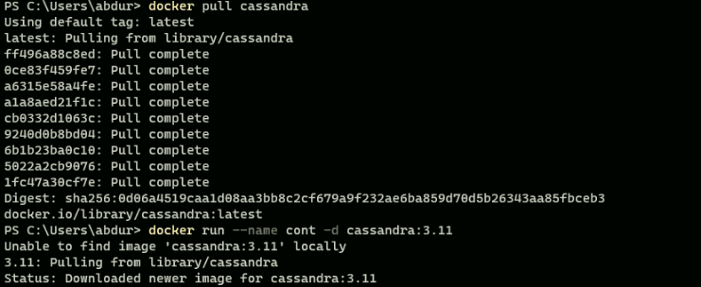

1. Check the downloaded images with

|  |
| --- |
| docker images |

Verify that *cassandra* is listed in the repositories column.

1. Now, you can run a container using the downloaded cassandra image using the convention:

|  |
| --- |
| docker run --name container-name -p 9042:9042 -d cassandra |

Here, container-name is the name you want to assign to your container. E.g. to create a container named cont2, you will run:

|  |
| --- |
| docker run --name cont2 -p 9042:9042 -d cassandra |

The option “-p 9042:9042” maps the port 9042 in the container to port 9042 on the host system.   
Port 9042 is used by the cassandra CQL shell. We will need access to it in order to forward queries to the cassandra cluster.

1. Verify that the container is running:  
   docker ps

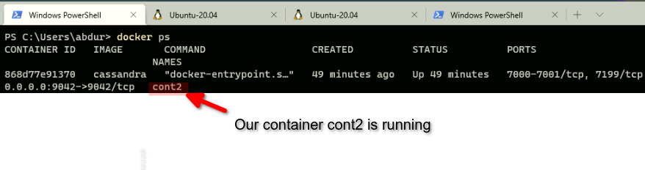

1. Now you can stop the container (and the cassandra cluster) when you do not need it. Your created databases and work will be preserved.

|  |
| --- |
| docker stop container-name |

Where container-name is the name of your container. Verify that the container has stopped with the docker ps command. Your container-name should not be listed in the output now.

The stopped container can be started again later:

|  |
| --- |
| docker start container-name |

References

1. <https://hub.docker.com/_/cassandra>
2. [How to use docker on debian 10](https://www.digitalocean.com/community/tutorials/how-to-install-and-use-docker-on-debian-10)
3. [Docker Container Networking](https://docs.docker.com/config/containers/container-networking/)

## 

## 